PATRONS  HRH The Prince Philip, Duke of Edinburgh KG, KT  HE Dr Peter Ammon, German Ambassador to the UK  HE Sir Sebastian Wood, KCMG, British Ambassador to Germany |  | 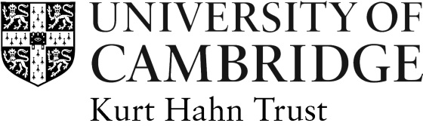

KURT HAHN TRUST APPLICATION FORM

Awards to German Students 2018-19

This form must be typed and hand written applications cannot be accepted. Please do not use staples or print double-sided.
Title: | Surname: |  | First Name:
College: | Nationality: |  | Date of birth:
Address (if not resident in College):

Email Address:
Qualification and Subject Sought :
(eg: PhD in Physics)

Length of time already spent on course at 1 October 2018:

Proposed Title for Research Thesis:

Previous Educational History and Qualifications already obtained. Please give dates and grade/class (e.g. MA in History, 1st class):

Level of Funding already obtained for course (please give details of sponsor etc.):
Other, i.e. non-academic, Interests etc. (please give details to demonstrate ‘evidence of more than usual enterprise, breadth of interest and social awareness’):

Declaration: I declare that the information given is correct, to the best of my knowledge.

Signed ………………………………………….………….. Date ………………………..
Once completed, this form should be returned by 5 March 2018, together with a CV and letters of support from two referees to:

The Secretary
Kurt Hahn Trust
International Student Office
17 Mill Lane
Cambridge CB2 1RX

