PATRONS  HRH The Prince Philip, Duke of Edinburgh KG, KT  HE Dr Peter Ammon, German Ambassador to the UK  HE Sir Sebastian Wood, KCMG, British Ambassador to Germany |  | 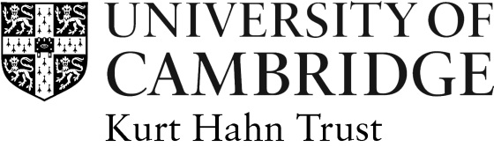

KURT HAHN TRUST APPLICATION FORM

Awards to German Students 2019-20

This form must be typed and hand written applications cannot be accepted. Please do not use staples or print double-sided.
Title: | Surname: |  | First Name:
College: | Nationality: |  | Date of birth:
Address (if not resident in College):

Email Address:
Qualification and Subject Sought :
(eg: PhD in Physics)

Length of time already spent on course at 1 October 2019:

Proposed Title for Research Thesis:

Previous Educational History and Qualifications already obtained. Please give dates and grade/class (e.g. MA in History, 1st class):

Level of Funding already obtained for course (please give details of sponsor etc.):
Other, i.e. non-academic, Interests etc. (please give details to demonstrate ‘evidence of more than usual enterprise, breadth of interest and social awareness’):

Declaration: I declare that the information given is correct, to the best of my knowledge.

Signed ………………………………………….………….. Date ………………………..

Data Protection
The personal information that you provide on this form will be used as necessary for the contractual purpose of assessing your application for the funding. It will be treated carefully and will only be shared with [insert details of who will see it in broad terms, especially if, e.g., the Colleges might see it]. For more information about how we handle your personal information, and your rights under data protection legislation, please see https://www.information-compliance.admin.cam.ac.uk/data-protection/general-data.

Once completed, this form should be returned by 4 March 2019, together with a CV and letters of support from two referees to:

The Secretary
Kurt Hahn Trust
International Student Office
17 Mill Lane
Cambridge CB2 1RX

Or via email to:
exchanges@admin.cam.ac.uk

